
Registration form


SECTION A

PROCEDURE FOR REGISTRATION

  - Complete all relevant sections, attach documents and all certificates.

  - Incomplete application forms without the relevant certificates will not be processed.

  - Upon completion, application forms, photos, certificates etc. can either be:

Scanned and emailed to registration@pirb.co.za or Posted to : P.O. Box 680, Wierda Park, Centurion, 0157

(it is recommended that if you are posting your application form please send it via registered mail and retain the registration tracking number) or

Hand delivery to PIRB Registration Office: 43 Estcourt Road, Unit 18, Wierda Park, Centurion.

  - All qualifications of any individual applying for registration will be vetted and verified with the various authenticating bodies.

  - The applicant will be notified via email/sms/telephone of any discrepancies that are found and the applicants application will be put on hold. The process of the application/registration will only continue once it has been addressed.

  - Once the application has been approved a pro-forma invoice for the yearly registration fee will be sent (current yearly registration fees can be found at www.pirb.co.za). The pro-forma invoice will be sent to the contact details that appear on the application/registration form.

  - Only once payment has been received, the PIRB will continue with the application and the application will be registered on the PIRB database. The PIRB registration card will then be sent to the applicant, if the applicant requested a card.

  - An Electronic format of the card will be available on the plumbers App.

  - The registration card will be sent via registered mail to the postal address that appears on the application form, or alternatively the PIRB Registration Card can also be collected from the PIRB registration office or collection points.

  - If the registration card is sent via registered mail the relevant tracking number will be sms’d to the applicant and it will be the applicants responsibility to keep track of the registered mail.

  - Any registered mail returned to PIRB office due to non-collection by the applicant will only be resent if an additional administration fee is paid. Alternatively it can be collected at the PIRB registration office.

  - If the application is found to be in order and payment of the invoice has been within a reasonable time, the PIRB registration process should not take longer than 20 working days from receipt of application.

  - Further information can be obtained from www.pirb.co.za or you may email registration@pirb.co.za

* The PIRB cannot and will not be held responsible for the Post Office courier services or lack thereof.

 | Registration card |  | Yes |  | NO

Registration fees does not include a registration card. Cards are available separately at a fee.
An electronic format of the card will be available on the plumber app

 | COLLECT |  | Registration MAIL |  |  |  |  | COURIER
 |  |  | To be completed by ALL Applicants
 | Application form completed in full |  |  |  | Declaration form signed (page)
 | Initial each page where relevant |  |  |  | Copy of ID

Colour ID Photo as per requirements (page )

- To be completed if applying for a Licensed/Plumber Qualification designation Copy of trade qualification – (if applicable)

- To be completed if applying for a specialisation designation

Copy of speculations certificate – (if applicable)

- To be completed if applying for a Master Plumber/Technical Operating Practitioner/Technical Assistant Practitioner

Proof of practicing experience – (if applicable) – (see Proof of Practicing experience form)
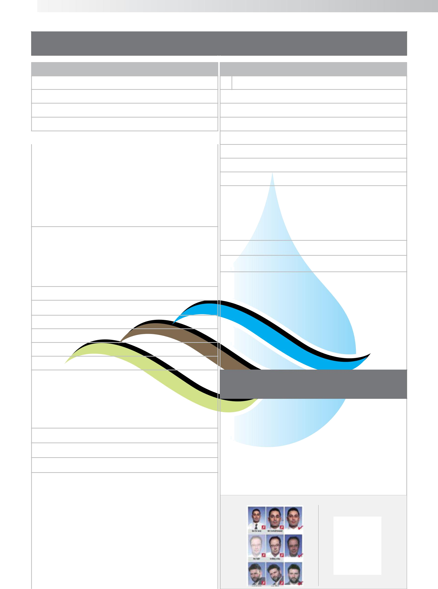
SECTION B
(To be completed by all applicants)

Personal Details

Title:

Firts Name:

Surname:

Identification Number:

* Attach a copy of your ID document to this application.

Gender: |  | Male |  | Female
Date of birth:
 |  | African |  | Coloured
Racial
Racial |  | Indian |  | White
Status: |  | Indian |  | White
 |  | Other

Home language:

Nationality:

Citizen |  | South African |  | Dual
Resident
Resident |  | Perm. Resident |  | Other
Status: |  | Perm. Resident |  | Other
Disability:

Physical Address:

Suburb: | Postal Code:
City:
Postal Address:

Suburb: |  | Postal Code:
Home:
Work:
Fax:
Mobile:
E-mail:
South African National |  |  | Yes |  | No

Current Employer Details

Employed Unemployed

Company Name :

Primary Contact Person:

Physical Address:

Suburb: | Postal Code:
City:
Postal Address:

Suburb: | Postal Code:
Work:
Company Vat nr:
Fax:
Mobile:
E-mail:

SECTION C - Photo Identification
(To be completed by all applicants)

- Photos must be no more than 6 months old

- Photos must be high quality

- Photos must be in colour

- Photos must have clear preferably white background

- Photos must be in sharp focus and clear

- Photo must be only of your head and shoulders

- You must be looking directly at the camera

- No sunglasses or hats

- Please affix photo in space provided with double sided tape. Do not use staples!

- If sent electronically only standard electronic formatted pictures photos. Please make sure the file name is your NAME and SURNAME.

Examples of Correct and Incorrect Photos

3.5 cm - 4.0 cm

cm | Affix
- 4.5 | Photo
- 4.5 | Here
05. cm

SECTION D

(Please tick relevant designation being applied for)


Director Plumber

Designation Requirements:

The following designation requirements must be observed to hold and maintain a Director Plumber Designation

- Must hold a Master Plumber Designation

- Must be a Director/Owner of Company (formal structure) and subject to a board review

- Obtain 45 CPD points over your respective 12 month registration cycle.

- Holds and maintains registration at the Institute of directors

- Re-register every 12 months.
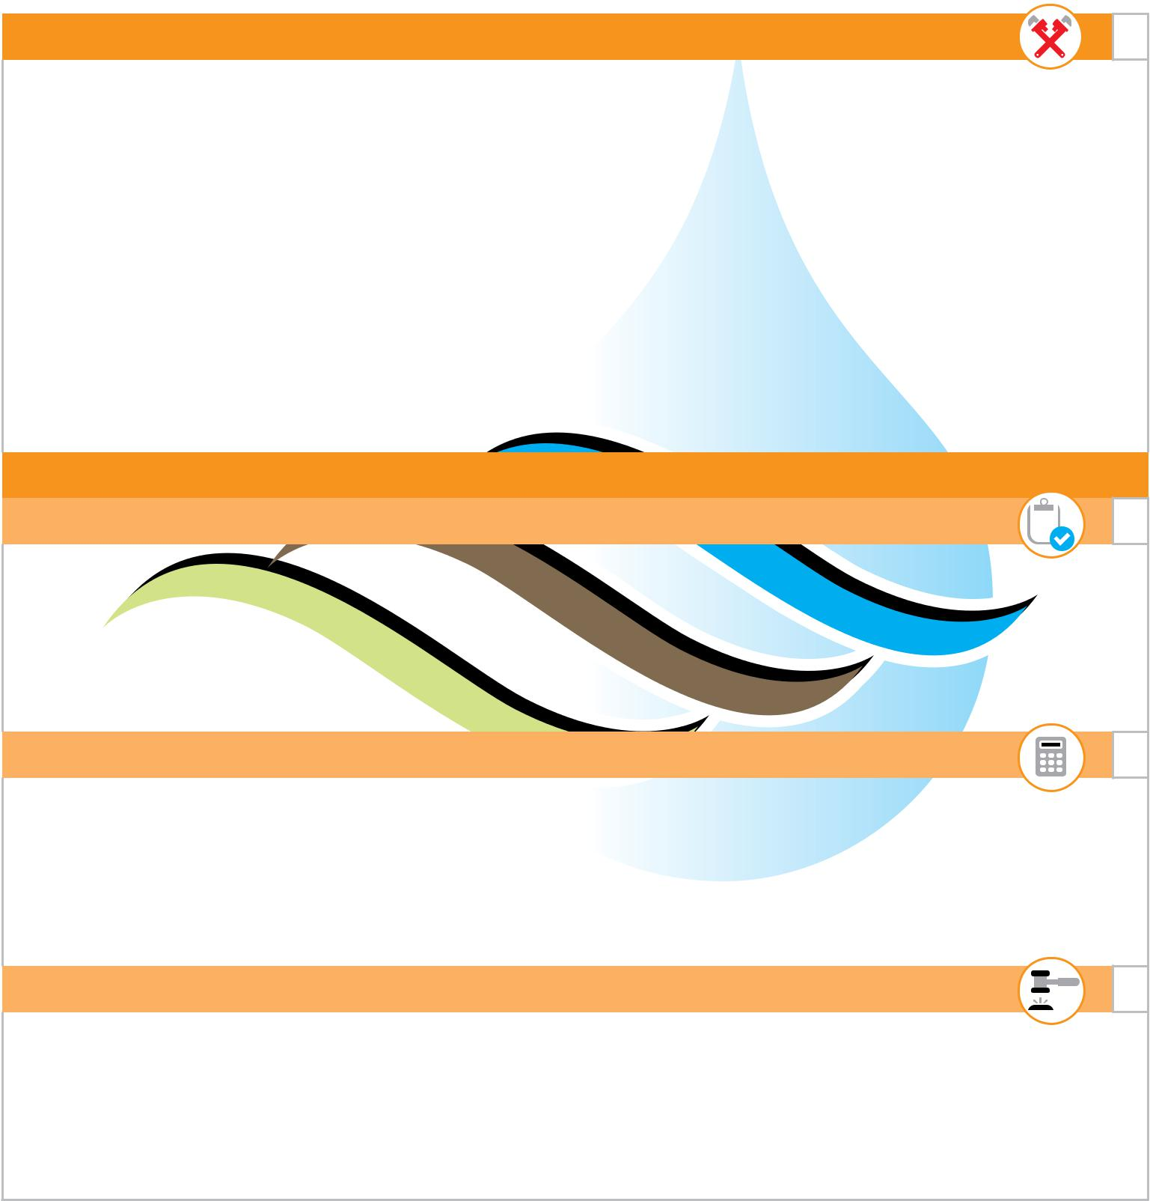

master Plumber

Designation Requirements:

The following designation requirements must be observed to hold and/or maintain a Master Plumber Designation

- Must hold a Licensed Plumbing Practitioner designation and at least one specialisation

- 10* Years Proven practicing experience in the plumbing industry (post qualification) and subject to a board review

- Obtain 35 CPD points over your respective 12 month registration cycle.

- Attend an accredited Business and leader ship management course or similar (credits)

- Pass the PIRB’s written Master Plumber test which includes – Technical, Business and leadership management

- Re-Register every 12 months.

* Proof of practicing experience from to be completed and accompany this application

Master Plumber Specialisations

Plumbing Training Assessor

Designation Requirements:

The following designation requirements must be observed to hold and/or maintain a Plumbing Training Assessor designation.

- Must hold a Master Plumber Designation

- Must have completed and passed a relevant accredited training assessors course.

- Pass PIRB’s Written board assessment for a Plumber Training Assessor

Plumbing estimator

Designation Requirements:

The following designation requirements must be observed to hold and/or maintain a Plumbing Auditor designation.

- Must hold a Master Plumber Designation

- Must have completed and passed the relevant PIRB accredited auditor course.

- Pass PIRB’s Written board assessment for a Plumbing Auditor

Plumbing Arbitrator

Designation Requirements:

The following designation requirements must be observed to hold and/or maintain a Plumbing Auditor designation.

- Must hold a Master Plumber Designation

- Must have completed and passed the relevant PIRB accredited auditor course.

- Pass PIRB’s Written board assessment for a Plumbing Auditor
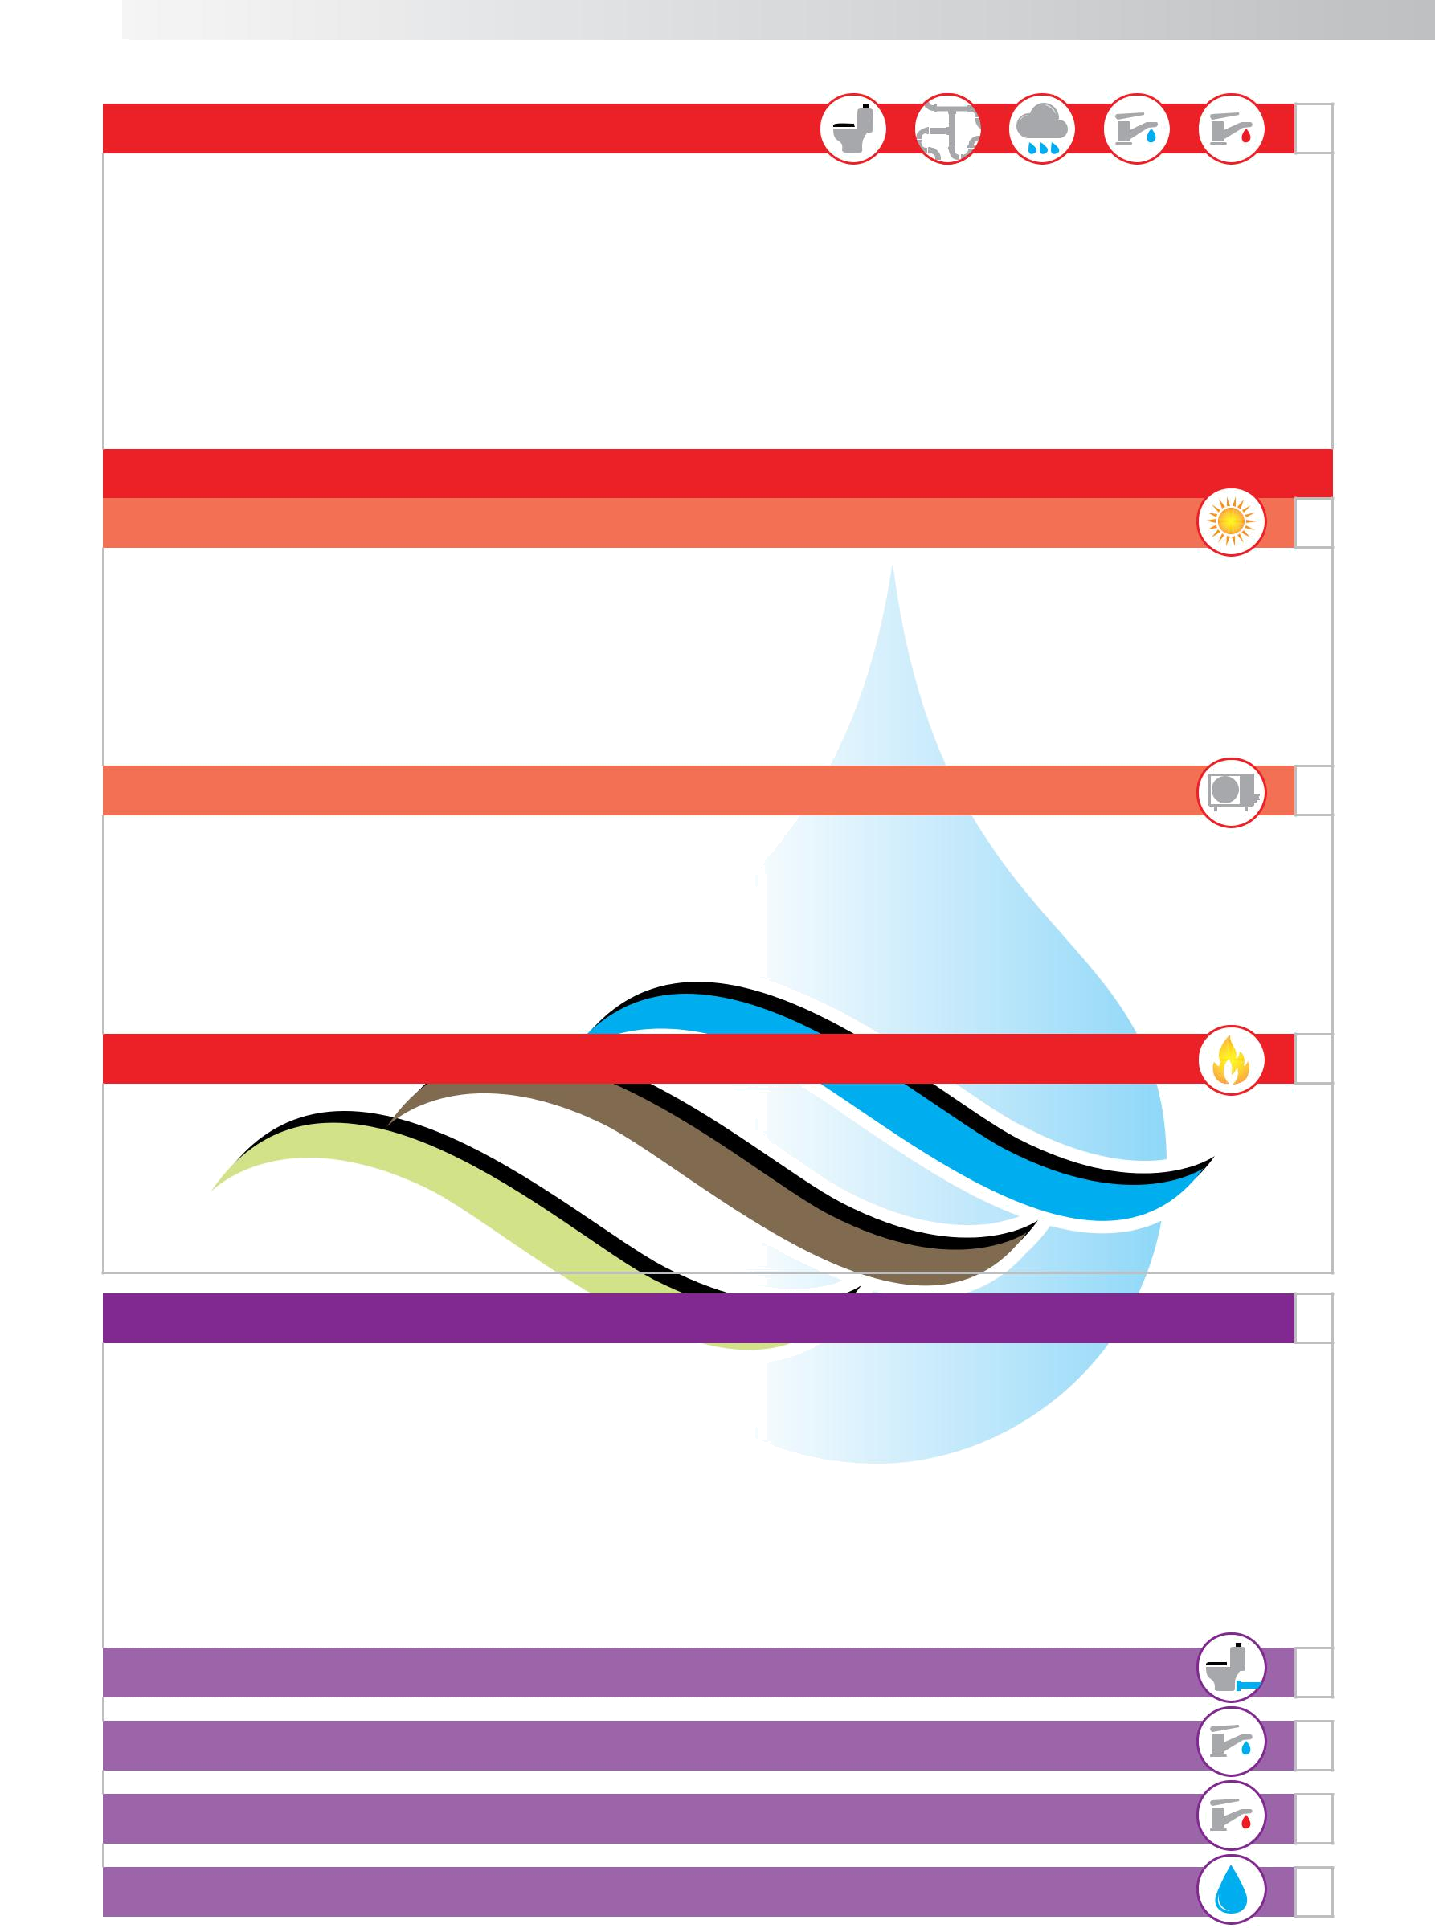
Licensed Plumber

Designation Requirements:

The following designation requirements must be observed to hold and/or maintain a Licensed Plumber Designation

- Must have completed and passed the relevant plumber trade teat as specified in the Manpower training act section 28 or 13 and/or have obtained a plumber qualification in terms of the Skills Development Act.

- Pass PIRB’s Practical and Written board assessment in the 5 Core PIRB designation levels

- Obtain 35 CPD points over your respective 12 month registration cycle.

- Re-Register every 12 months.

Licensed Plumber Specialisations

Licensed Plumber - Solar

Designation Requirements:

The following designation requirements must be observed to hold and/or maintain a Licensed Plumber Solar Specialisation Designation
- Must hold a Licensed Plumber Designation

- Must have completed and passed the relevant PIRB approved Solar Water Heating accredited training.
- Pass PIRB’s Practical and Written board assessment in Solar Hot Water Heating

Licensed Plumber – Heat Pump

Designation Requirements:

The following designation requirements must be observed to hold and/or maintain a Licensed Plumber Solar Specialisation Designation
- Must hold a Licensed Plumber Designation

- Must have completed and passed the relevant PIRB approved Heat Pump Hot Water Heating accredited training.
- Pass PIRB’s Practical and Written board assessment in Heat Pump Hot Water Heating

Licensed Plumber – Gas

Designation Requirements:

The following designation requirements must be observed to hold and/or maintain a Licensed Plumber Solar Specialisation Designation
- Must hold a Licensed Plumber Designation
- Holds and maintains registration at SAQCC(Gas).
- Pass PIRB’s Practical and Written board assessment in gas

Technical Operator Practitioner

Designation Requirements:

The following designation requirements must be observed to hold and/or maintain a Technical Operator Practitioner designation

  - 3* Years Proven practicing experience in the plumbing industry and respective designation being applied for.

  - Pass the PIRB’s Practical test for each respective technical operator practitioner designation being applied for.
  - Obtain 10 CPD points over 12 month cycle.
  - Re-Register every 12 months.
* Proof of practicing experience from to be completed and accompany this application

Technical Operator Practitioner – Drainage Technical Operator Practitioner – Cold Water Technical Operator Practitioner – Hot Water

Technical Operator Practitioner – WATER ENERGY EFFICIENCY
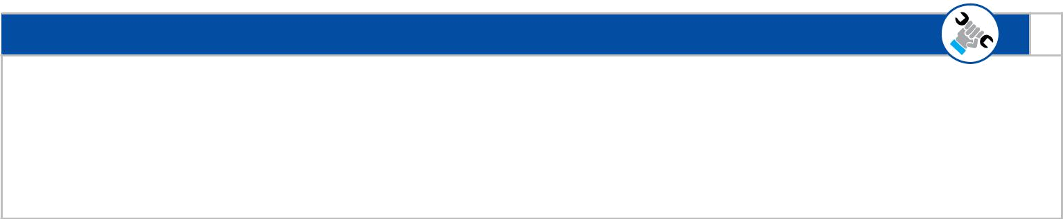
Technical Assistant Practitioner

Designation Requirements:

The following designation requirements must be observed to hold and/or maintain a Technical Assistance Practitioner designation
- 3 Years Proven practicing experience in the plumbing industry.
- Obtain 5 CPD points over 12 month cycle.
- Re-Register every 12 months.


Learner

Designation Requirements:

The following designation requirements must be observed to hold and/or maintain a Learner designations

- Must preferably be employed and must work under the supervision and/or mentorship of a Licensed or Qualified Plumber.

- Provide details of the PIRB Licensed/Qualified Plumber under whose adequate supervision and/or mentorship you will be doing your plumbing training.
- Obtain 10 CPD points over 12 month cycle.
- Re-Register every 12 months.

SECTION E

All PIRB registered Qualified Plumber, Licensed Plumber, Master Plumber and director Plumber Designations Qualified plumber and above shall have in their possession the current compulsory SANS codes of Practice. Building Regulations and Local Water Bylaws documentation for ease of reference. (Copy of the SANS regulations can be obtained from South Africa Bureau of Standards and or the Institute of Plumbing of South Africa (IOPSA)

Please tick the boxes acknowledging that you have the relevant documentation

 | SANS 10254 | The installation, maitenance, replacement and repair of Fixed Electric
 | SANS 10254 | Storage Water Heating Systems.
 | SANS 10252 | Water supply and drainage for building Part 1: Water supply installations
 | SANS 10252 | for buildings.
 | SANS 10252 | Water supply and drainage for building Part 2: Drainage installations for
 | SANS 10252 | buildings.
 | SANS 10400 | National Building Regulations.
 | SANS 10106 | The installation, maitenance, replacement and repair of a Solar Water
 | SANS 10106 | Heating Systems.
 | SANS 1352 | The installation, maitenance, replacement and repair of Domestic Air
 | SANS 1352 | Pumps Source Water Heating Heat Pumps Systems.
 | Local Authority | The relevant Local Authority Water Bylaws where you are operating in.
 | Water Bylaws:

DECLARATION

(To be completed by all applicants)

PIRB’S PLUMBERS CODE OF CONDUCT:

- PIRB registered plumbers agree to conduct themselves and their business in a professional manner which shall be seen by those they serve as being honourable, transparent and fair.

- PIRB registered plumbers agree to proactively perform, work and act to promote plumbing practices that protect the health and safety of the community and the integrity of the water supply and wastewater systems.

- PIRB registered plumbers agree to promote, protect and encourage the upliftment and advancement of the skills development and training in terms of the National Skills ACT. for themselves and individuals in the plumbing sector or wishing to join the plumbing industry. PIRB registered plumbers agree to monitor and enforce compliance with technical standards of plumbing work that comply with all requirements of the relevant SANS codes of practice and regulations set out in the compulsory National Standards of the Water Service Act 1997 Amended (8th June2001) as well as relevant local municipal bylaws.
- PIRB registered plumbers agree to actively promote and support a consistent and effective regulatory plumbing environment throughout South Africa.

- PIRB registered plumbers agree to regularly consult and liaise with the plumbing industry in an open forum free of any political or commercial agenda for the discussion of matters affecting the plumbing industry and the role of plumbing for the well-being of the community and the integrity of the water supply and wastewater systems.

- PIRB registered plumbers agree to promote, monitor and maintain expertise and competencies among our registered and non-registered plumbing professionals.

- PIRB registered Licensed plumbers agree to issue a PIRB Plumbing Certificate of Compliance (COC) on all plumbing works undertaken as a PIRB Licensed Plumber and shall further issue the COC in terms of the prescribe requirements for issuing of a PIRB Plumbing COC.


ACKNOWLEDGEMENT

- As part of the PIRB registration process, all qualifications of any individual applying for registration is vetted and verified with various authenticating bodies. If it is found that the relevant authenticating bodies have no knowledge or records of the relevant individuals qualification it will be forwarded to the PIRB Steering Committee to be reviewed. Only once the PIRB steering committee have reviewed your trade test result and gave authorization will be the PIRB register the relevant individual. Further to this if the verification bodies at any stage communicate to the PIRB that the relevant individuals qualification is no longer valid for reason beyond the PIRB’s control, the PIRB reserve the right to remove the PIRB status of the registered individual with immediate effect and the PIRB will not be held liable for any possible damages that may arise from this. It will further not be the responsibility of the PIRB to address or follow this up with the authenticating body.

- • I acknowledge that plumber registration is an annual registration and that a registration fee is charged for plumber registration and this fee which is subject to change is to be paid into the PIRB bank account before I am to be registered.

- • I acknowledge that I must reapply for re-registration, one calendar month before the renewal date that appears on my registration card and that the PIRB reserves the right to level a penalty fee for late registration.

- • I acknowledge that the Plumbing Industry Registration Board has the authority to suspend or terminate my registration if I act against the best interest of the PIRB, its aims and objectives and the PIRB’s Plumbers Code of Conduct. I further acknowledge that in the event of a suspension and or termination the PIRB’s reserves the right to notify this fact publically and the reason for the suspension and/or termination.

- • I acknowledge that if I register for the designation of a Licensed / Qualified Plumber including any specialisations, I shall agree to issue a PIRB Plumbing Certificate of Compliance (COC) on all plumbing works undertaken as a PIRB Licensed Plumber.

- I acknowledged that the issuing of the PIRB Plumbing COC shall be done in the strict defined terms of the prescribe requirements for issuing of a PIRB Plumbing COC and acknowledge that random audits will take place on the COC’s and that I will give full cooperation in this regard.

- • I acknowledge that as a Licensed Plumber if I fail to issue a PIRB Plumbing Certificate of Compliance (COC) for work undertaken, carried out and or work adequately supervised; and a complaint is raised against the said plumbing works and or my actions; and the said plumbing works and or my actions are found to be contra to the PIRB’s Code of Conduct, I may and can be held accountable for all cost incurred in resolving the said complaint.

DECLARATION

I__________________________________________identification number___________________________________Declare that the information contained in this application, or attached by me to this application, is complete, accurate and true to the best of my knowledge. I further declare that by forwarding this completed application form to the PIRB I am acknowledging that I have read and fully understood what is required of me as a PIRB registered and professional plumber and that I adhere to all aims and objectives of the PIRB and the PIRB’s Plumber Code of Conduct. I give consent for enquiries for verification purposes to be made into any information I have given on this application.

Signature of applicant:______________________________ Date:________________________________________


Tel: | 0861 747 275 |  | Fax: 0866 927 230 |  | SAQA Professional Body
Email: info@pirb.co.za / registration@pirb.co.za |  |  |  | www.pirb.co.za | Recognition Number:
Physical Address |  |  | Postal Address | www.pirb.co.za | PIRB831
43 Estcourt Road |  |  | P.O. Box 680
Wierda Park |  |  | Wierda Park
Centurion 0157 |  |  | Centurion, 0149

